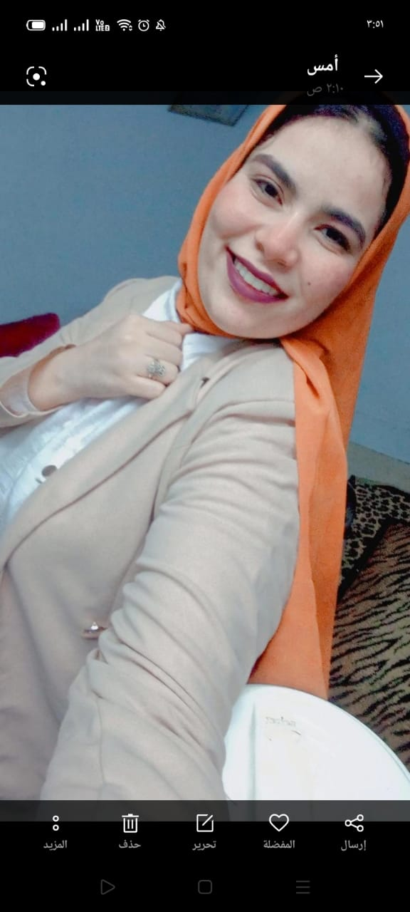
Wafaa Ali Alsayed mahmoud
Contact
- Address: Elwadi elgadid, Elkarga
-E-mail: wafaaali@aun.edu.eg
Education
-B.Sc. Basic science in nursing, Faculty of nursing, Assiut University, Grade: Excellence, 2021
Work Experience
Demonstrator at geriatric nursing department Faculty of nursing Assiut university
Language Skills:
- Arabic: Native, English: Good.
IT Skills: -
Microsoft Office Programs (Word – Excel – PowerPoint)
Intra Personal Skills: -
Creative, self-motivated, reliable and dynamic, Flexible, sociable, leadership and Presentation skills, Negotiation, work under stress, Collaborative, motivate people, team work ability and loves to make friends.
Training & courses
- Infection control Training
- First Aid Training
- ICDL course
- English language course
- Statical analysis in scientific research training
- Research Ethics
- Teacher preparation course
- Electronic course design
- BLS course
Conferences
Future of Nursing: Health Problems, Challenges and Solutions 18-19 February, 2024

